Guided Capstone Project Report

**Introduction:**

In this report we are going to discuss various factors affect ticket prices at Big Mountain resort and recommendations to capitalize on the opportunities and resources we have at the resort.

**Problem:**

The purpose of this data science project is to come up with a pricing model for ski resort tickets in our market segment. Big Mountain suspects it may not be maximizing its returns, relative to its position in the market. It also does not have a strong sense of what facilities matter most to visitors, particularly which ones they're most likely to pay more for. This project aims to build a predictive model for ticket price based on a number of facilities, or properties, boasted by resorts.

**Findings and recommendations:**

From initial analysis and modeling we found few feature which may be useful for predicting ticket prices of the resort.

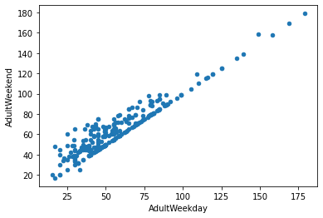

Here we predict Weekend ticket prices since there is almost linear relationship between Adult weekend and Adult weekday prices and since Adult weekend prices have fewer missing values you choose it as our target variable.

Features that came up as important in the modeling included:

* vertical_drop
* Snow Making_ac
* total_chairs
* fastQuads
* Runs
* LongestRun_mi
* trams
* SkiableTerrain_ac

We have below options at our hand:

1. Permanently closing down up to 10 of the least used runs.
2. Increase the vertical drop by adding a run to a point 150 feet lower down but requiring the installation of an additional chair lift to bring skiers back up, without additional snow making coverage
3. Same as number 2, but adding 2 acres of snow making cover
4. Increase the longest run by 0.2 mile to boast 3.5 miles length, requiring an additional snow making coverage of 4 acres

We assume the expected number of visitors over the season is 350,000 and, on average, visitors ski for five days.

### **Scenario 1**

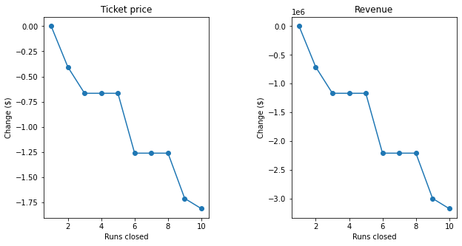

The model says closing one run makes no difference. Closing 2 and 3 successively reduces support for ticket price and so revenue. If Big Mountain closes down 3 runs, it seems they may as well close down 4 or 5 as there's no further loss in ticket price. Increasing the closures down to 6 or more leads to a large drop.

### **Scenario 2:**

In this scenario, Big Mountain is adding a run, increasing the vertical drop by 150 feet, and installing an additional chair lift. This scenario increases support for ticket price by $1.99 and over the season, this could be expected to amount to $3474638. Hence this step is supported by our model.

### **Scenario 3:**

In this scenario, you are repeating the previous one but adding 2 acres of snow making. This scenario increases support for ticket price by $1.99 and over the season, this could be expected to amount to $3474638.Such a small increase in the snow making area makes no difference! Hence, we don’t recommend increasing snow making area.

### **Scenario 4:**

This scenario calls for increasing the longest run by .2 miles and guaranteeing its snow coverage by adding 4 acres of snow making capability. After analyzing the step with our model, we find that it makes no difference with ticket prices and hence we don’t recommend this step.